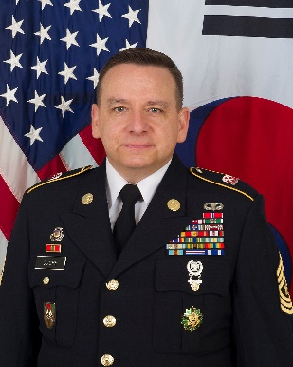
Sergeant Major Stuart Coupe is a native of Jerome, ID enlisting into the U.S. Army in 1985. He completed Basic Training at Fort Knox, KY and Advanced Individual Training at Aberdeen Proving Grounds, MD. In May 2023, he assumed responsibilities as the Senior Enlisted Advisor, Reserve Forces Policy Board, Washington, DC.

His previous assignments include: Reserve Personnel Management Directorate SGM - Army Human Resources Command, Fort Knox, KY; Senior Enlisted Advisor -Army Reserve Engagement Cell, Korea; G-3/5/7 SGM 9th Mission Support Command, Fort Shafter, HI; Senior Enlisted Advisor -Army Reserve Engagement Cell - US Army Pacific, Fort Shafter, HI; Promotions and Professional Development SGM - HODA G-1, Washington, DC; Army Reserve CSM Executive SGM- Office of the Chief Army Reserve, Washington, DC; Director of Instruction/Deputy Commandant - NCO Academy, Camp Parks, CA; Enlisted Policy Coordinator- HODA G-1, Washington, DC; Senior Enlisted Advisor - US National Support Element, Kabul, Afghanistan.

Sergeant Major Coupe has attended all levels of Non-commissioned Officer Professional Development to include the Nominative Leaders Course. His other military training includes the First Sergeants Course, Senior Enlisted Joint Professional Development Course, Defense Support of Civil Authority Course and the Airborne Course.

Sergeant Major Coupe holds a Bachelor of Fine Arts degree in Photography from the University of Idaho.

Sergeant Major Coupe's awards include: Legion of Merit, Bronze Star Medal, Meritorious Service Medal (8th Award), Army Commendation Medal (3rd Award), Army Achievement Medal (3rd award), Army Good Conduct Medal (8th award), Global War on Terrorism Expeditionary Medal, Afghanistan Campaign Medal w/ bronze campaign star, Global War on Terrorism Service Medal, Military Outstanding Volunteer Service Medal, NCO Professional Development Ribbon (6th award), Army Service Ribbon, Overseas Service Ribbon (3rd Award), Army Reserve Component Overseas Training Ribbon, Parachutist Badge, Army Staff Identification Badge, Korea Defense Service Medal, National Defense Service Medal, NATO Medal. His additional achievements include being the sole non-commissioned officer recipient of the Headquarters Department of the Army Pace Award.
Sergeant Major Coupe is married to Elisa and they have three children.

